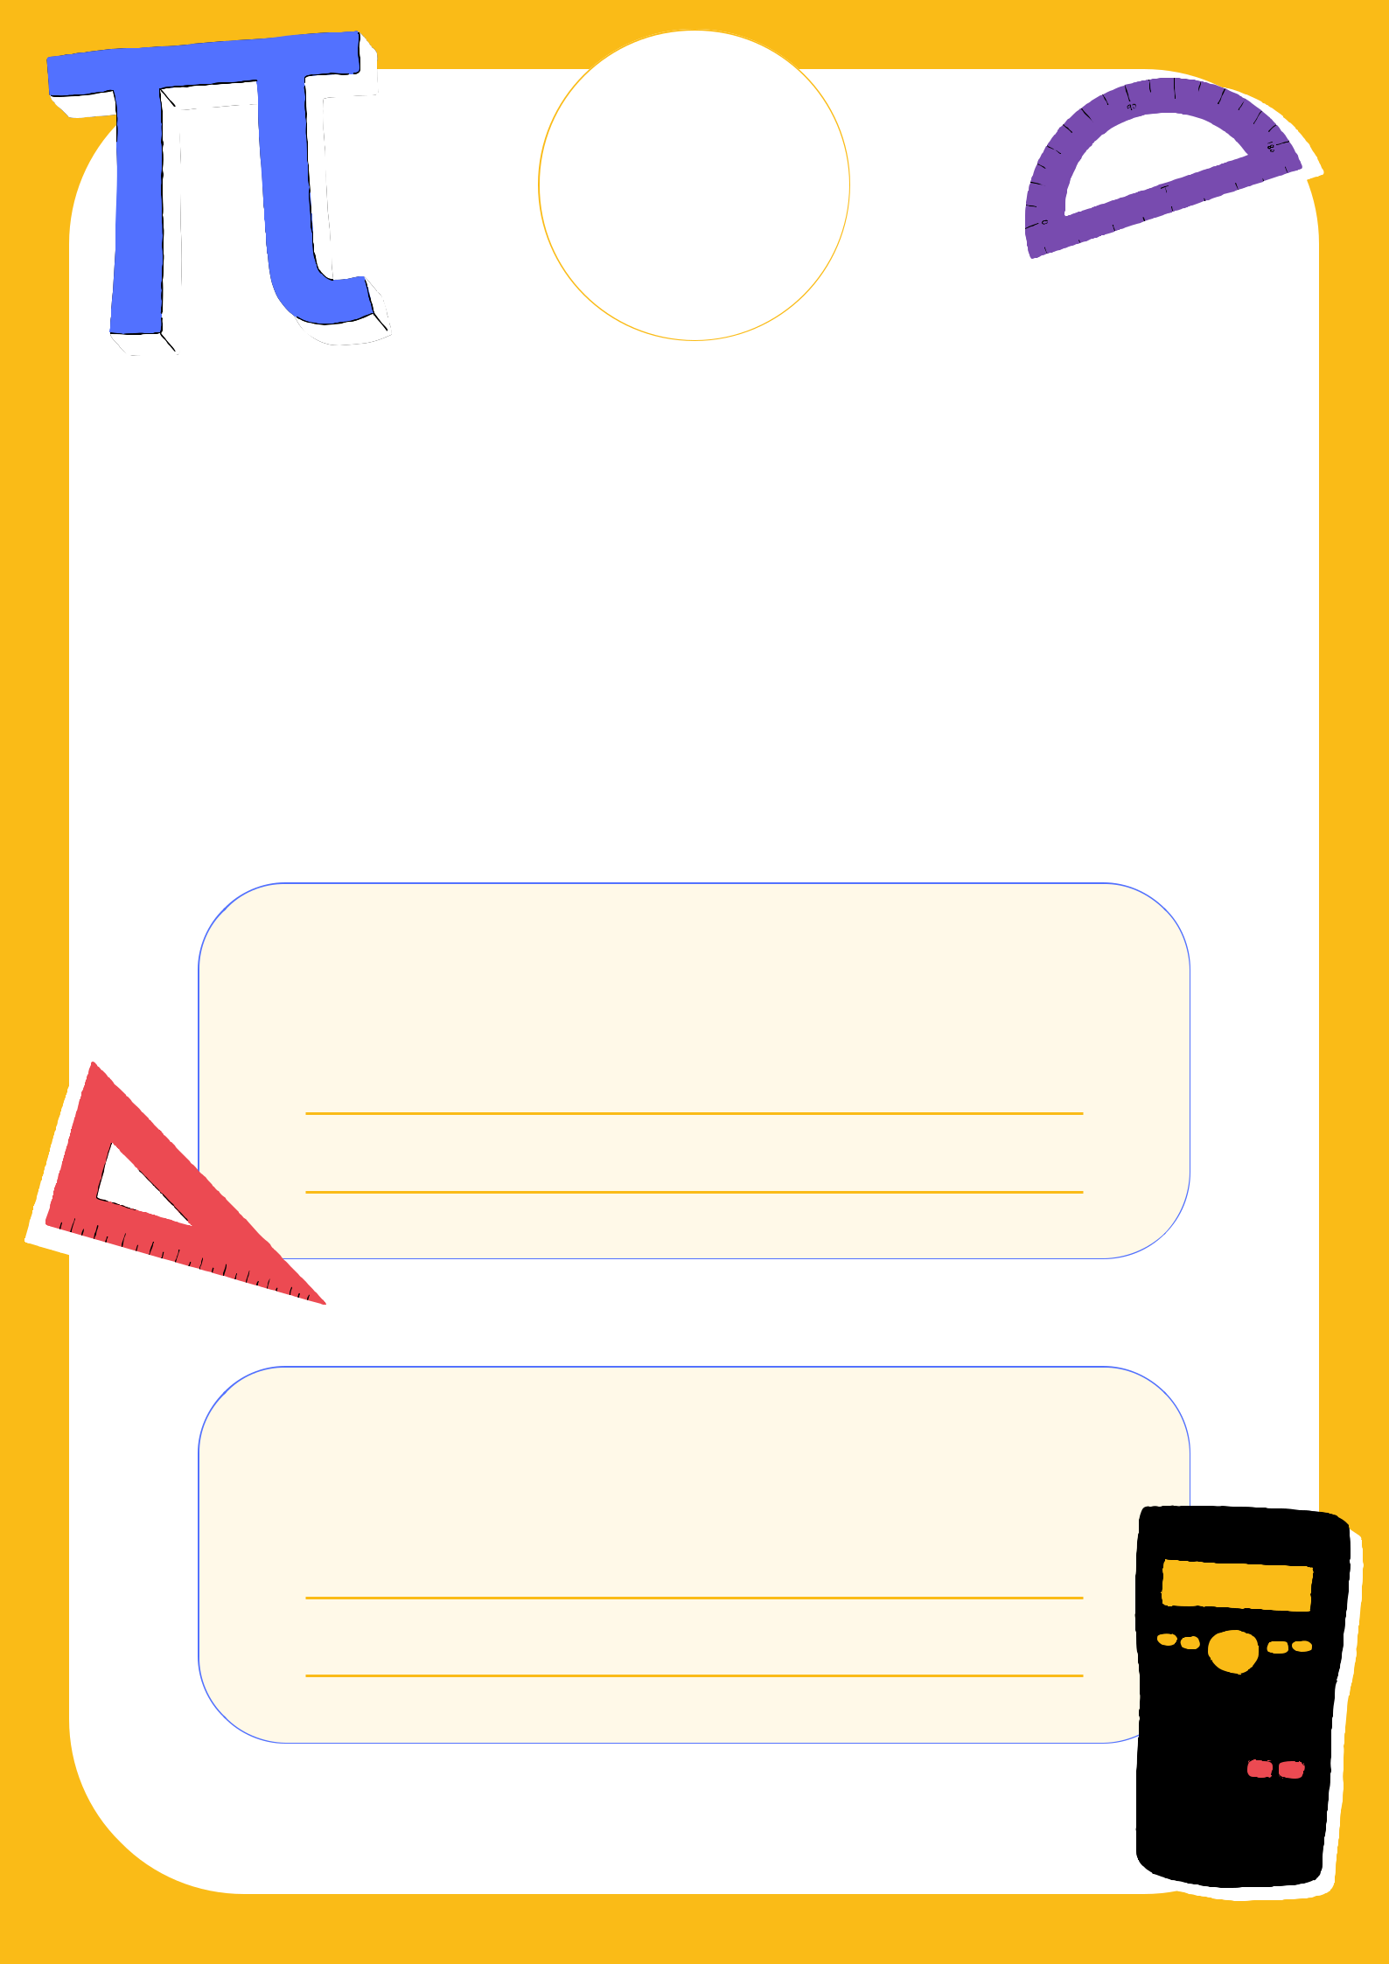
School
Logo

Maths

Project

Topic:

Prepared by:

