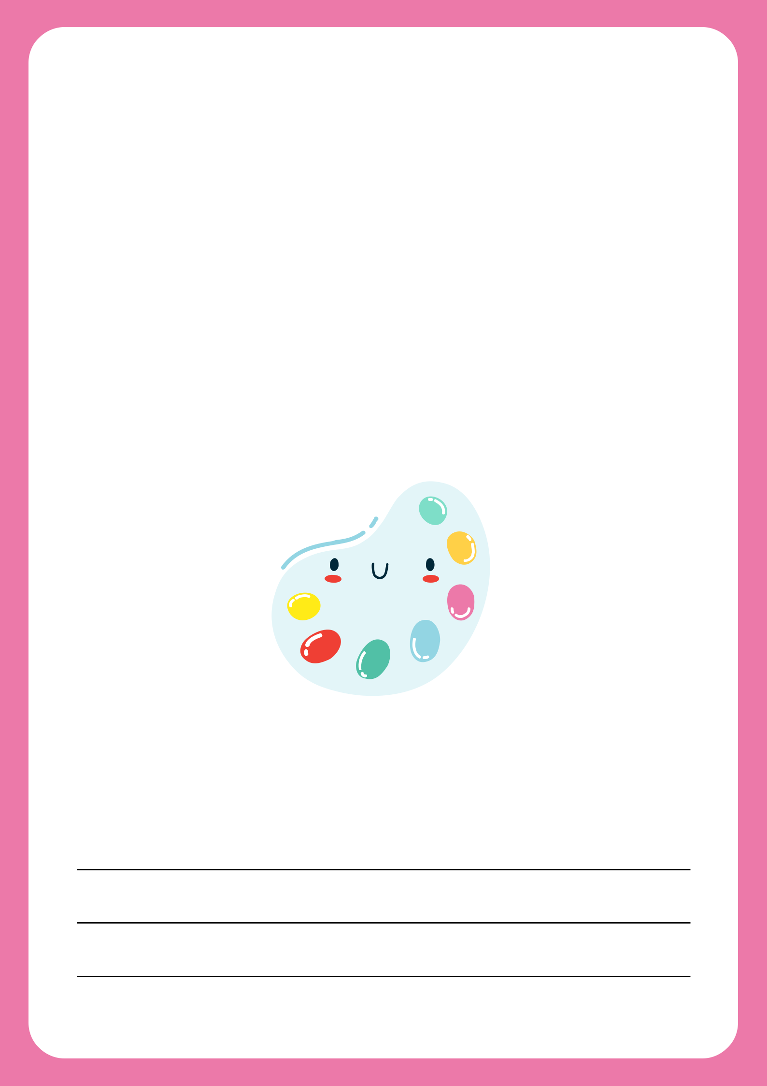

Science

Student's name:

Class Period:

School Year:

8

